*Week* 3

**DeMorgan’s Theory Explained:**

**Theorem 1**: Theorem states that two or more variables NAND’ed together is the same as the two terms inverted and OR’ed



**Thereon 2:** Theorem states that two or more variables NOR’ed together is the same as the two variables inverted and AND’ed



**DeMorgan’s Theorem illustrated in Gates (Schematic):**

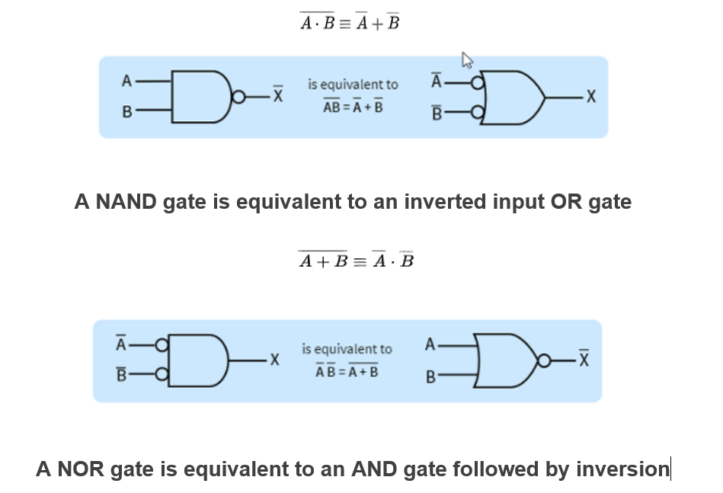

Lets to go video to work out an example: Refer to video example:

DeMorgan’s Theorem

F1 = F2

Implementation of SOP expression with NAND Gates: Inverter

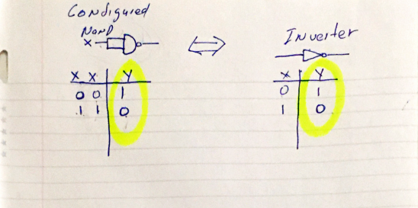

Karnaugh Maps (K – Map)

* A Karnaugh map is a graphical representation of a logic function.
* The map for n-input logic function is an array with 2N cells,(One for each possible input combination or minterm.
  + 2 variables 🡪 4 cells; 3 variables 🡪 8 cells
* To represent a logic function o a k-map, we simply copy 1’s from the truth table to the corresponding cells in the K-Map.
* Implicants are squares or rectangles made up of minterms
* Pairs of adjacent “1” cells in the K-map have minterms that differ in ONLY one variable
* The minterm pairs can be combined into a single product term using the generalization of theorem T10:
  + T10 = Term * Y + Term * Y’ = (Term)
* Thus, we can use k-map to simplify the sum of the function.

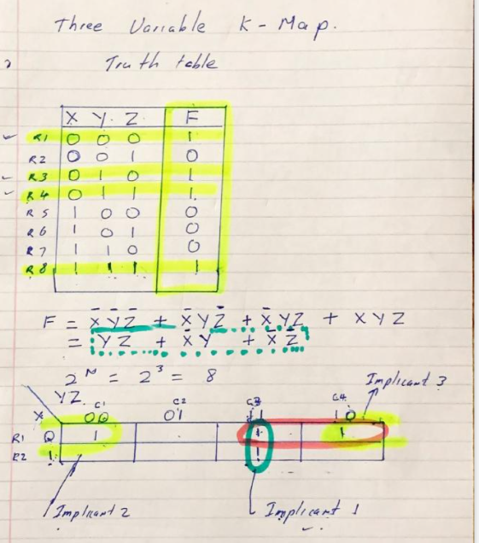

**Combinational circuit -Small Design Summary**

Truth table:

LUT (LOOK UP TABLE)

Entire truth table ..

Advantage:

Disadvantage:.

Minimal logic circuit Implementation

Advantage:

Disadvantage: